|  |
| --- |
| detail of persons hands with scissors, markers, workingSOFTWARE REQUIREMENT SPECIFICATION |

|  |  |  |
| --- | --- | --- |
| Team Lost |  |  |
| Li Jin Quan U1722463A  Lee Jian Hao U1721619C  Chen Xing Yu U1721205J | Kok Jia Hui U1721022E  Tee Wan Yi U1721844C |  |

TABLE OF CONTENTS

Introduction 4

Purpose 4

Stakeholders and Users 4

Product Scope 4

Overall Description 5

Product Functions 5

User Classes and Characteristics 5

Operating Environment 5

User Documentation 5

Assumption and Dependencies 6

External Interface Requirements 7

User Interfaces 7

Hardware Interfaces 7

Software Interfaces 7

Communications Interfaces 8

System Features 9

Feature #1: View Health Tips 9

Feature #2: Browse News 9

Feature #3: Choose healthcare premises 9

Feature #4: Search healthcare premises 10

Feature #5: Book healthcare appointment 10

Feature #6: Manage healthcare appointment 11

Feature #7: View FAQ 11

Feature #8: Search FAQ 12

Feature #9: Submit Feedback 12

Feature #10: Retrieve geographical data 12

Feature #11: Login 13

Feature #12: View Feedback 13

Feature #13: Send appointment details 13

Feature #14: Retrieve news 14

Feature #15: Register 14

Feature #16: Logout 14

Other Non-functional Requirements 16

Reliability Requirements 16

Performance Requirements 16

Safety Requirements 16

Supportability Requirements 16

Security Requirements 16

Software Quality Attributes 16

Business Rules 17

Other Requirements 18

Database Requirements 18

Legal Requirements 18

Glossary 19

Analysis Models 20

Class Diagrams 20

State-transition Diagrams 20

Key Boundary Diagrams 21

Use Case Diagrams 22

System Architecture 23

# Introduction

## Purpose

TeamLost will design and develop a website to assist people in finding the nearest healthcare premise. The purpose of this website is to provide users with the ability to book an appointment at the desired healthcare upon successful search. The aim of this function is to provide convenience for the users, at the same time, saving their time. In addition, this website eliminates the hassle of calling the healthcare premise to query about the appointment. This website supports detailed searches by providing different categories to scale down the search, making it more fast and accurate. This website provides category such as Hospital, Polyclinic, Dentals and CHAS clinic.

## Stakeholders and Users

Stakeholders of TeamLost are project developers, system users and project supervisor. Project developers contribute to the creation of the website. They are also the system administrators who are responsible in managing the website. System users are anyone living in Singapore. They can use this website to search for the nearest healthcare premises and book healthcare appointment at the desired healthcare premises. Project supervisor is the lab supervisor who provides valuable guidance throughout the development process and will evaluate the product.

## Product Scope

TeamLost is a web based system with 2 key features. It allows users to find the nearest healthcare premises in Singapore as well as book healthcare appointment at the desired healthcare premises. One of the benefit of this website is to help users to save time of queueing as it allows user to book healthcare appointment online at different healthcare premises. The website also supports auto-detection of location. This feature is convenient to users as it will automatically display the healthcare premises within 2km on the map. The goal is to deliver most reliable service with simple interface to benefit every users.

# Overall Description

## Product Functions

Any user will have access to the website main functions, like:

1. Search for nearest healthcare premise
2. Book an appointment at the desired healthcare premise
3. View healthcare related tips and news

## User Classes and Characteristics

The website target audience is anyone living in Singapore. It is very likely that young adults, aging from 25 to 40, will frequent our website the most, as they are comfortable and proficient in using electronic devices. In addition, young adults are usually busy with work, which is the reason why they would usually seeks for services that help them save their time. There will be a drop in usage for user aged 20 and below as there is lesser need for them to visit a healthcare premise. Likewise, there will always be a drop in terms of frequency of use for elderly since they are more comfortable with real time query and they tend to trust and rely on real time query more than the computer.

## Operating Environment

The system will perform on any platform which provides Internet and supports Browser, such as Google Chrome and Firefox.

## User Documentation

There will be a step-by-step guide for any first time user, as well as elderly to learn how to operate through the website efficiently.

1. User must be logged in in order to use the main functions
   1. If user does not have an account
      1. Click on Register at the top right hand corner of the homepage/any page
      2. Enter all the required fields requested
      3. Click on Register to complete the Registration process
      4. Proceed to the Login page to log in to the website.
2. If the user wishes to view all nearest healthcare premises,
   1. The user can go to Health Services-> Select desire healthcare premise
   2. The user can choose to allow system to automatically detect their location, or they can manually enter their location.
   3. The system will then mark their entered location with a star, and user can check all nearby healthcare premises around the star.
3. If the user wishes to route to the desired healthcare premises from their current location/entered location,
   1. The user can go to Health Services-> Select desire healthcare premise
   2. The user can choose to allow system to automatically detect their location, or they can manually enter their location.
   3. The user checks on the routing checkbox.
   4. The user will then select the destination from the drop-down-list.
   5. The system will then display the route and the entered location will be marked with “A”, and the destination will be marked as “B”
4. If the user wishes to book an appointment,
   1. The user can go to Appointment -> Book Appointment.
   2. The user can choose to allow system to automatically detect their location, or they can manually enter their location.
   3. The system will display all the nearest healthcare premises within 2km.
   4. After user select one desired healthcare premise, select Next to proceed.
   5. After entering the desired date and time, select Next to proceed
   6. After checking the particulars, select Save to book the appointment.
5. If the user wishes to send feedback regarding the website,
   1. The user can go to Help
   2. After entering the Feedback Title and Feedback, select Submit Feedback
6. If the user have any question(s),
   1. The user can go to Help
   2. Under the submission of Feedback, a list of FAQ is displayed.
   3. Subsequently, the user can also type in keyword to search for relevant question(s).

## Assumption and Dependencies

Users are assumed to have experience in using computers and internet. We also assume that internet connection is available when using the system.

1. NewsAPI
2. oneMap
3. data.gov.sg
4. Nexmo
5. medicalnewstoday.com

|  |
| --- |
|  |

# External Interface Requirements

## User Interfaces

Login:

This is for the Administrator and user to get into the system. It requires a login ID and password.

Registration:

This utility is to create new user for the system.

Dashboard:

This page able users to edit or delete appointment.  This page shows all the appointment of the particular user.

Feedback Creation:

Registered user can submit a new feedback by entering the feedback details.

Feedback Submitted:

Once the feedback is submitted, a successful message will be shown.

View feedback:

Admin can view the all of the feedback.

Appointment Booking:

Registered user can book a new appointment by entering all the appointment details.

Appointment Deletion:

Once the appointment is deleted, a successful message will be shown and a SMS will be sent to user.

Appointment Updated:

Once the appointment is updated, a successful message will be shown and a SMS will be sent to user.

Logout:

This is for the Administrator and user to exit the system.

## Hardware Interfaces

Hardware interface:  Google Chrome, Firefox, Internet Explorer, any browser that support internet connection

## Software Interfaces

Client:  A browser that supporting JavaScript

Frontend: tailwind css, bootstrap css, vueJS framework javascript

Backend: laravel framework php, MySQL database,

## Communications Interfaces

The  system  uses PHP  as server language  and hence requires HTTPS for  transmission of data. More over this allows easy interaction between the various clients and the server.

# System Features

## Feature #1: View Health Tips

* Description and Priority
* Description: Allowing users to view health tips on home page of the website.
* Priority: Low.
* Benefit: Broaden user’s health knowledge.
* Stimulus/Response Sequences
* User actions: Users can navigate through the slide of images.
* System response: System will change the slide within a period of time automatically.
* Functional Requirements
* Software capabilities:
  + 13. The user must be able to view health-related tips
* Invalid input response: -

## Feature #2: Browse News

* Description and Priority
* Description: Allow users to browse health-related news on home page of the website.
* Priority: Low.
* Benefit:

1. Broaden user’s health knowledge.
2. Give tips to those users who required health guidance.

* Stimulus/Response Sequences
* User actions: Users can find out more by clicking on the title of the new.
* System response: System will bring users to the respective URL.
* Functional Requirements
* Software capabilities:
  + 14 The user must be able to view health-related news
* Invalid input response: -

## Feature #3: Choose healthcare premises

* Description and Priority
* Description: Allowing user to select their desired healthcare premises.
* Priority: High.
* Benefit:

1. Easy and quick search of healthcare premises nearby.
2. With the use of our detection system, user’s location will be detected and it saves the time for user to enter their address.

* Stimulus/Response Sequences
* User actions: Users can make selection across the various healthcare premises.
* System response: System will display all the healthcare premises that is nearby the location detected/entered.
* Functional Requirements
* Software capabilities:
  + 2. The user shall be able to make selection of various healthcare premises given by the system.
  + 5. The system must be able to locate healthcare premises based on the entered location.
    - 5.1 The user shall be able to select the desired hospital
    - 5.2 The user shall be able to select the desired clinic
    - 5.3 The user shall be able to select the desired pharmacy
    - 5.4 The user shall be able to select the desired dental
  + 6. The user must be able to view address of selected healthcare premises.
* Invalid input response: -

## Feature #4: Search healthcare premises

* Description and Priority
* Description: Searching of healthcare premises nearby.
* Priority: High.
* Benefit:

1. User’s location will be automatically detected by our system.
2. Allow user to search by entering specified location around Singapore.

* Stimulus/Response Sequences
* User actions: User can enter the location where they want to do a search on.
* System response: System will display map of all the nearby healthcare premise that user searched on.
* Functional Requirements
* Software capabilities:
  + 3. The user shall enter the desired location
  + 4. The user shall allow detection of their current location
  + 5. The system must be able to locate healthcare premises based on the entered location.
    - 5.1 The user shall be able to select the desired hospital
    - 5.2 The user shall be able to select the desired clinic
    - 5.3 The user shall be able to select the desired pharmacy
    - 5.4 The user shall be able to select the desired dental
  + 6. The user must be able to view address of selected healthcare premises
* Invalid input response:

1. Detection of current location disabled.
2. Invalid/Wrong location entered.

## Feature #5: Book healthcare appointment

* Description and Priority
* Description: Allows user to make healthcare appointment at desired healthcare premises.
* Priority: High
* Benefit:  Help to save users’ time as it eliminates the hassle of calling the healthcare premise to book an appointment.
* Stimulus/Response Sequences
* User actions:  User fill up appointment details at book appointment page.
* System response: System sends appointment details to users via SMS.
* Functional Requirements
* Software capabilities:
  + 7. The user must enter user data to book an appointment.
* Invalid input response: Next button will be disabled.

## Feature #6: Manage healthcare appointment

* Description and Priority
* Description: Allow user to manage healthcare appointment which includes making changes to appointment or cancelling appointment.
* Priority: High.
* Benefit:

1. Changes made will be sent to user by system via SMS. This enable user to keep track of any changes made and prevent user from looking at the wrong message.
2. Deletion of appointment will also notify user via SMS which allows user to be aware of the action taken by them.

* Stimulus/Response Sequences
* User actions: User can select “Edit” to edit healthcare appointment.
* System response: System will retrieve all the details of the booked healthcare premise and allow user to only make changes for the date/time and return a successful message.
* User actions: User can select “Delete” to delete healthcare appointment.
* System response: System will delete the record of the selected appointment and return a successful message.
* Functional Requirements
* Software capabilities:
  + 8. The user shall be able to make changes to their medical appointment using their NRIC
    - 8.1 The user shall edit their medical appointment
    - 8.2 The user shall cancel their medical appointment
* Invalid input response:

1. Invalid format of appointment date and time entered

## Feature #7: View FAQ

* Description and Priority
* Description: Allowing users/administrator to view Frequently Asked Questions (FAQ).
* Priority: Low
* Benefit: FAQ will be able to answer some of the questions, or technical difficulties user might have/faced when using the website.
* Stimulus/Response Sequences
* User actions: The user selects “Help” on the navigation bar.
* System response: The system will direct user to the FAQ page, where all the frequently asked questions are displayed.
* User actions: The user clicks on the question that he/she wants to view.
* System response: System displays answer for the selected question.
* Functional Requirements
* Software capabilities:
  + 9. The user must be able to view frequently asked question (FAQ)
* Invalid input response: NIL

## Feature #8: Search FAQ

* Description and Priority
* Description: Allows user to search for frequently asked question (FAQ).
* Priority: Low
* Benefit: FAQ will be able to answer some of the questions, or technical difficulties user might have/faced when using the website.
* Stimulus/Response Sequences
* User actions: The user enters question or keyword of the question that he/she wants to view in the search field
* System response: System displays the frequently asked question with relevant keyword.
* Functional Requirements
  + Software capabilities:
    - 10. The user must be able to search frequently asked question (FAQ)
  + Invalid input response: Invalid keyword entered.

## Feature #9: Submit Feedback

* Description and Priority
* Description: Allowing user to submit feedback.
* Priority: Low
* Benefit: To improve on the user experiences when using the website by providing constructive feedbacks that will help to improve the website.
* Stimulus/Response Sequences
* User actions:  The user is required to enter feedback details.
* System response: The system displays successful message.
* Functional Requirements
* Software capabilities:
  + 11. The user must enter feedback details before submitting feedback at the feedback page
* Invalid input response:

1. Feedback details not filled up.

## Feature #10: Retrieve geographical data

* Description and Priority
* Description: oneMap provide geographical data upon triggered by user.
* Priority: Medium
* Benefit: oneMap is able to provide reliable and accurate geographical data upon request.
* Stimulus/Response Sequences
* User actions: The user will enter the location that he/she wished to query on. System response: The system will return all the nearest healthcare premises located based on the location provided by the user.
* Functional Requirements
* Software capabilities:
  + 4. The user shall allow detection of their current location.
    - 4.1 The system must be able to detect user’s current location
  + 5. The system must be able to locate healthcare premises based on the entered location.
    - 5.1 The user shall be able to select the desired hospital
    - 5.2 The user shall be able to select the desired clinic
    - 5.3 The user shall be able to select the desired pharmacy
    - 5.4 The user shall be able to select the desired dental
  + 6. The user must be able to view address of selected healthcare premises
* Invalid input response:

1. Detection of location disabled.

## Feature #11: Login

* Description and Priority
* Description: Allow user to login to book appointment and admin to login to manage feedback.
* Priority: High.
* Stimulus/Response Sequences
* User actions: User/admin enter login details (login ID and Password).
* System response: User and admin will be directed to their individual respective page.
* Functional Requirements
* Software capabilities:
  + 7. The user must enter user data to book an appointment
    - 7.1 The user must login to the system before they can book appointment
  + 8. The user shall be able to make changes to their medical appointment using their NRIC
    - 8.1 The user shall edit their medical appointment
    - 8.2 The user shall cancel their medical appointment
* Invalid input response:

1. Wrong login details.

## Feature #12: View Feedback

* Description and Priority
* Description: Allow system administrator to view feedback submitted by users.
* Priority:  Medium
* Benefit: To improve on the user experiences when using the website by viewing feedbacks that users submitted.
* Stimulus/Response Sequences
* User actions: Admin enter login ID and password to login into system.
* System response: The system will direct to the admin site.
* User actions:  The system administrator selects “view feedback” option.
* System response: The system will display all the feedbacks submitted by user.
* Functional Requirements
  + Software capabilities:
    - 12 The Admin shall be able to view the feedbacks submitted only
  + Invalid input response: -

## Feature #13: Send appointment details

* Description and Priority
* Description: Sending SMS will be sent to user when user successfully booked/deleted/updated an appointment.
* Priority: High.
* Benefit:

1. User will be able to check their appointment without having to log in.
2. Give user double confirmation about their actions so that they will be aware of what is done.

* Stimulus/Response Sequences
* User actions: User successfully booked an appointment.
* System response: Appointment details will be sent via third-party service (Nexmo).
* Functional Requirements
* Software capabilities:
  + 7.2 The system must send appointment details to user via SMS upon successful booking
* Invalid input response: -

## Feature #14: Retrieve news

* Description and Priority
* Description: Display of healthcare news.
* Priority: Low.
* Benefit: Update user with latest healthcare news or tips.
* Stimulus/Response Sequences
* User actions: User can click on the title of the news.
* System response: System will retrieve the URL from third-party API (NewsAPI) and bring user to that page.
* User actions: -
* System response: System will retrieve all latest news from the API and display it.
* Functional Requirements
  + Software capabilities:
    - 14 The user must be able to view health-related news
      * 14.1 The system must be able to retrieve the health-related news
  + Invalid input response: -

## Feature #15: Register

* Description and Priority
* Description: Allowing user to create an account in order to book appointments.
* Priority: High
* Stimulus/Response Sequences
* User actions: The user will have to fill up all the fields.
* System response: The system validate all the fields entered by users and direct user to the login page after user has been registered successfully.
* Functional Requirements
* Software capabilities:
  + 1. The user must be able to register an account to be able to use certain functions
    - 1.1 The system must be able to validate user input to ensure that they entered the correct format
* Invalid input response:

1. The user enters NRIC/phone number/name in wrong format.
2. The required field is not filled up.
3. The user registers account with NRIC that is already registered.

## Feature #16: Logout

* Description and Priority
* Description: Log user/admin out of the system.
* Priority: Medium
* Stimulus/Response Sequences
* User actions: User click on ‘Log out’ in order to be logged out of system.
* System response: System will log user out of the system and redirect user back to the login page.
* Functional Requirements
* Software capabilities:
  + 15 The user must be able to logout
* Invalid input response: -

# Other Non-functional Requirements

## Reliability Requirements

In case of system failure, the system will make use of backup server while the main server is being fixed.

## Performance Requirements

When an appointment is booked/deleted, the system must be able to update the database within 10 seconds. The system must be able to retrieve information from google map within 5 seconds.

## Safety Requirements

One of the possible loss from using of product is loss of personal information. However, our database ensure that data are kept secured since we used google cloud to store information from our database. Google cloud provide a lot securities, which include, network security, application security and data security.

## Supportability Requirements

The system database will be updated according to the latest version of MySQL, which is used in our system.

## Security Requirements

Users’ personal information including health information will be strictly kept confidential and will not be disclosed to others.

## Software Quality Attributes

* Adaptability
* The system is able to run on most browser, platforms and operating system.
* Availability
* Website will be available for 24/7.
* Correctness
* Location of user will be accurate and error-free.
* Flexibility
* Incorrect date/time chosen can be changed easily. In the future, any new department can be easily added without interfering the current design.
* Interoperability
* The system communicates closely with the database to provide reliable storing and retrieving of information.
* Maintainability
* Website and database are maintained by our administrators daily.
* Portability
* Database can be ported to new system easily.
* Reliability
* Database are able to withstand huge amount of data and our website will not be slow down despite the huge amount of data.
* Reusability (developer)
* ‘Time-picker’ and ‘Date-picker’ are components that are store in separate file and can be reused over and over again.
* Robustness
* Able to cope with input validation errors such as email format, NRIC format and telephone number.
* Testability
* The system testability is high because all the source codes are well- organised, which in return, giving us the capability to find any faults in the system easily.
* Usability
* Easy to use, idiot-proof.

## Business Rules

* User
* If user want to do modification regarding their booked appointment, they can change date/time/preferred doctor/health condition.
* If user wish to change the location of their appointment, they have to cancel the current appointment and rebook the appointment with the new location they want.
* Without enabling geographical location, user location will not be detected and they have to enter the location themselves.

# Other Requirements

## Database Requirements

* Database must store huge amount of data without slowing down the system.
* Database will always be backed up as soon as any modification is/are made.
* Database can be recovered easily from back up.

## Legal Requirements

* Conforms to The Data Protection Act.
* Company information
* Image license

# Glossary

Actor: A person, software system, or hardware device that interacts with a system to achieve a useful goal. Also called a user role.

Assumption: A statement that is believed to be true in the absence of proof or definitive knowledge.

Constraints: A restriction that is imposed on the choices available to the developer for the design and construction of a product.

Functional requirement: A statement of a piece of required functionality or a behaviour that a system will exhibit under specific conditions.

Scope: The portion of the ultimate product vision that the current project will address. The scope draws the boundary between what’s in and what’s out for the project.

Stakeholder: A person, group, or organization that is actively involved in a project, is affected by its outcome, or can influence its outcome.

Use case: A description of an interaction between an actor and a system that results in an outcome that provides value to the actor.

Use case diagram: An analysis model that identifies the actors who can interact with a system to accomplish valuable goals and the various use cases that each actor will perform.

Class Diagram: An illustration of the relationships and source code dependencies among classes in the Unified Modeling Language (UML).

# Analysis Models

## Class Diagrams

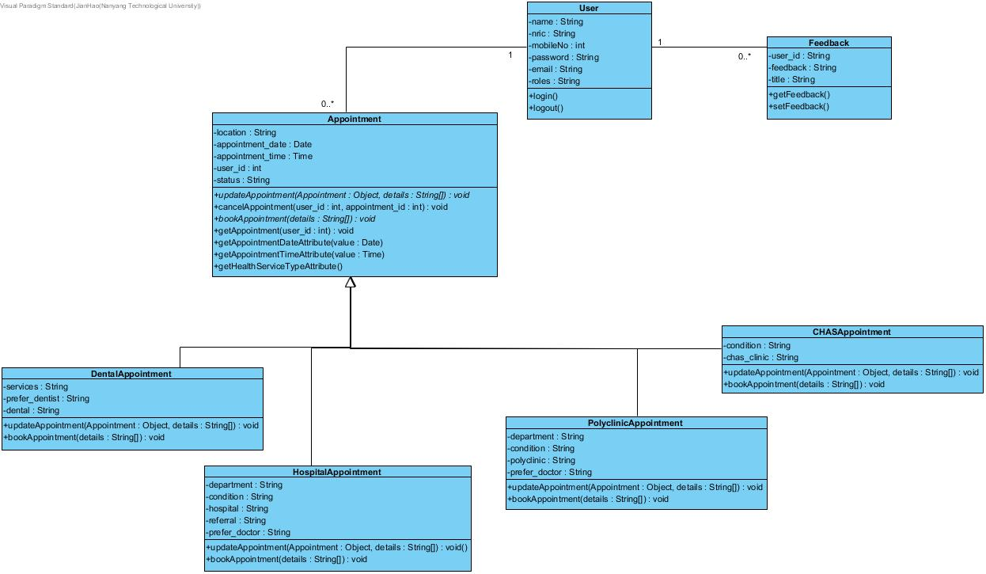

## State-transition Diagrams

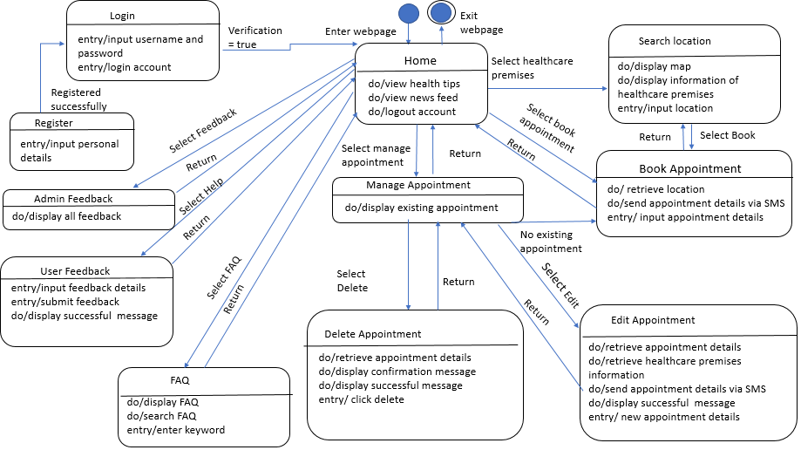

## Key Boundary Diagrams

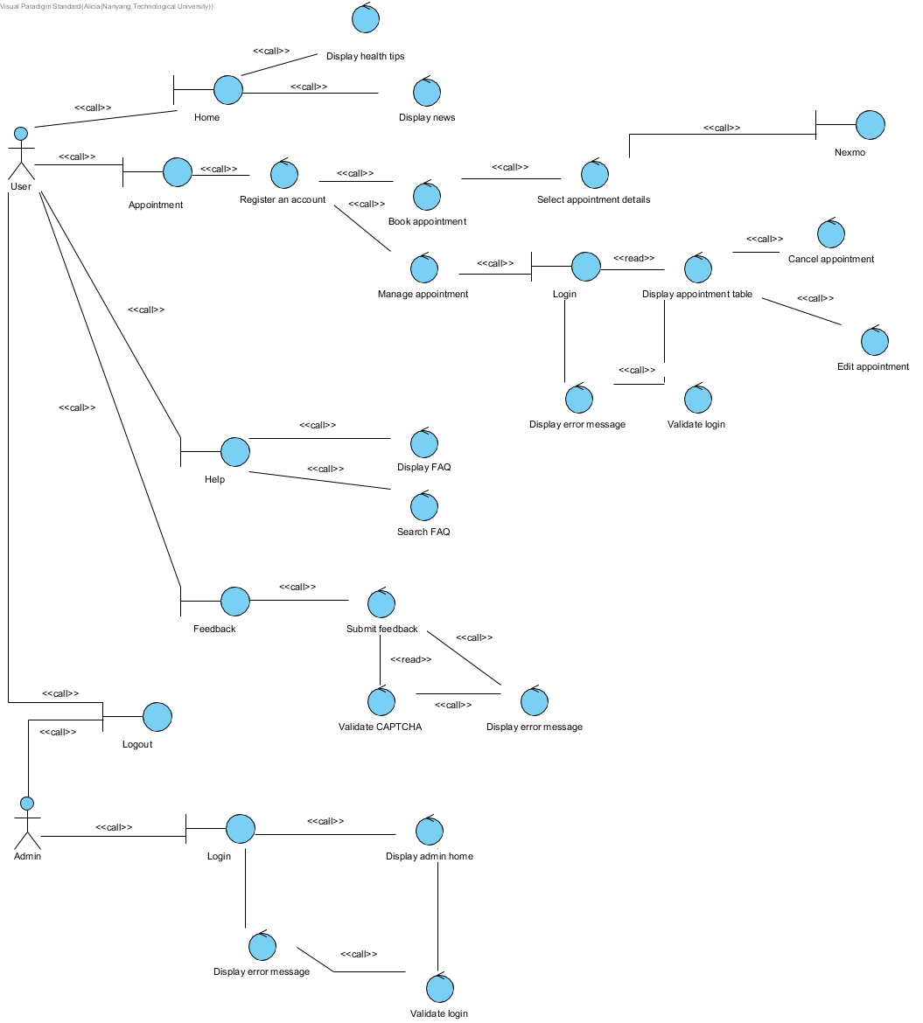

## Use Case Diagrams

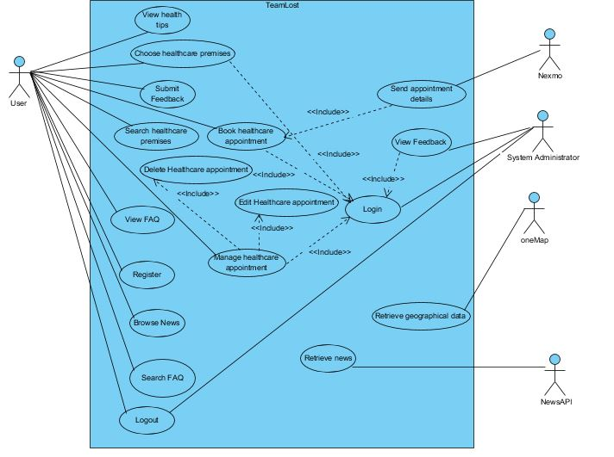

## System Architecture

